SCHOOL MANAGEMENT PLATFORM

NEXATECH Student Monitor
A connected view of school operations and student progress
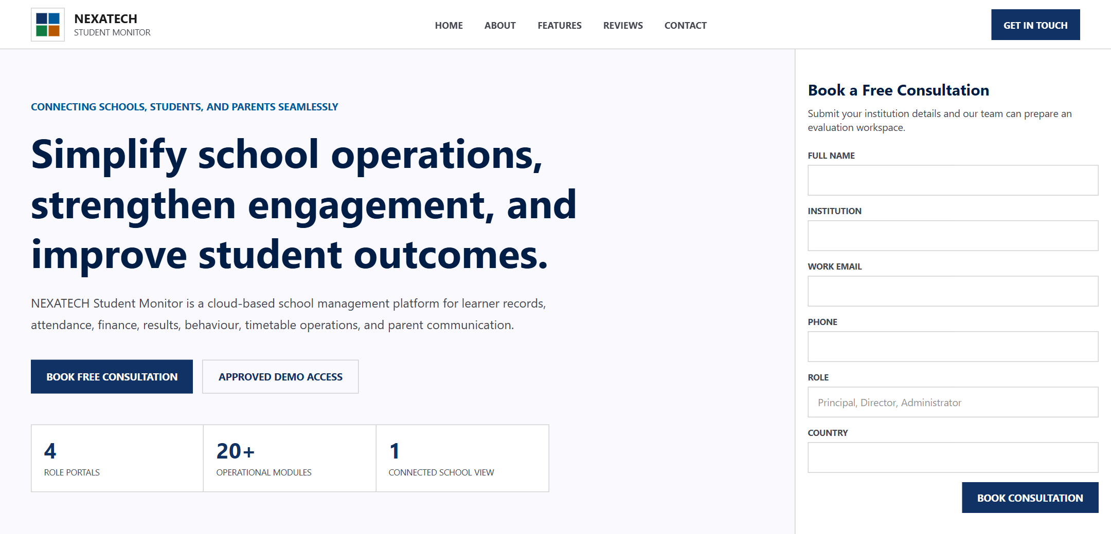
A professional entry point for consultations and controlled demonstration access
NEXATECH Student Monitor brings the information a school uses every day into one organised system. Administrators can oversee learner records and operations, teachers can manage academic work, parents can follow their children, and finance teams can track school accounts with role-appropriate access.
- Clear oversight. A single workspace reduces fragmented records and makes current information easier to find.
- Stronger follow-up. Attendance, results, behaviour, fees, and communication records support earlier action.
- Controlled access. School data remains separated by institution, with permissions shaped around each user role.

School Operations in One Workspace
The management portal gives school leaders a concise operational summary while keeping the full set of modules close at hand. Staff move from student administration to academics, communication, timetables, finance, examinations, and reports without switching between disconnected tools.
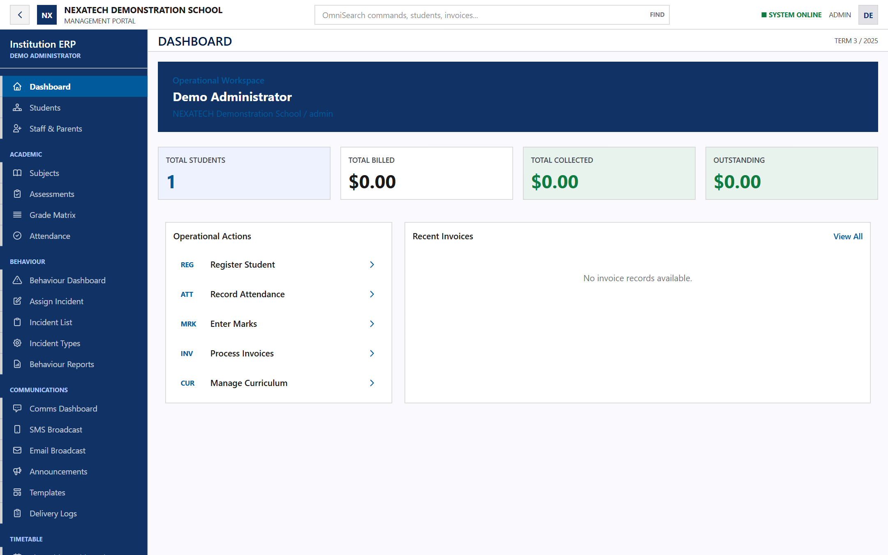
Administrator dashboard with operational summaries and direct access to school modules

Core System Coverage
Operational area | What the system supports
Student administration | Manage learner profiles, class placement, parent links, status, and school records from one workspace.
Academic management | Configure subjects and assessments, enter marks, review class results, and prepare report cards.
Attendance and behaviour | Record attendance, document incidents, review patterns, and support timely follow-up.
Finance | Manage fee structures, invoices, payments, expenses, income categories, and cashbook activity.
Timetables | Organise periods, rooms, teacher availability, class timetables, and examination schedules.
Communication | Share announcements and manage email or SMS communication with visible delivery records.

Student Information That Staff Can Act On
Learner profiles form the link between academic, attendance, behaviour, billing, timetable, and parent-facing information. Search and filters help staff reach the right record quickly, while school and role restrictions limit what each user can view or change.
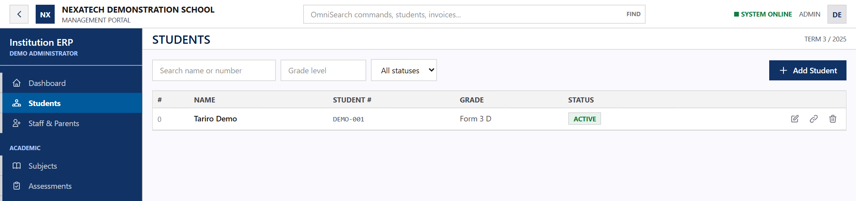
Searchable student register shown with synthetic demonstration data

Designed Around School Roles
- School leaders and administrators. Monitor operations and manage the records, workflows, users, and settings that keep the institution running.
- Teachers. Work with attendance, assessments, marks, behaviour, student records, and teaching timetables.
- Parents and guardians. Use a dedicated portal to view linked children, including attendance, results, fees, behaviour, timetables, announcements, and report cards.
- Finance teams. Manage invoicing, payments, expenses, categories, cashbook records, and financial summaries.

A Practical Path to Adoption
Schools can begin with an approved read-only demonstration using synthetic data, then plan configuration, user setup, data preparation, and staff onboarding around their own operating model. The platform is designed to support a controlled rollout rather than exposing real school records during evaluation.
Request a consultation or approved demo to explore the system

